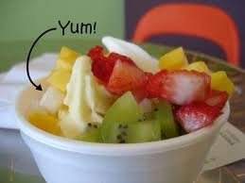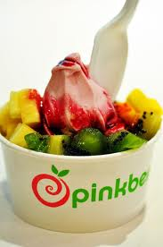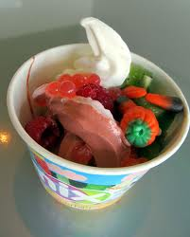 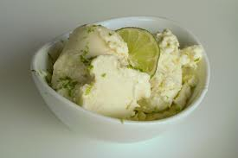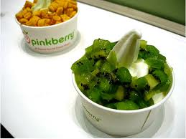  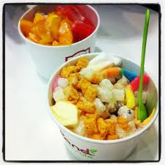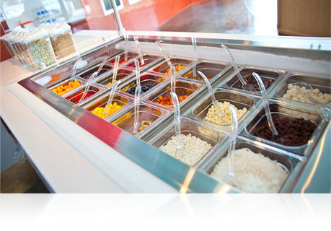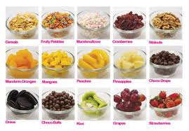 

Our company practices good ethics and closely follows our core values. Our company hires based on the employee’s aptitude to follow these core values. Compared to other companies, we provide quality food and service, and we aim to help the environment while giving the customer what they want.

## What we Do

We gather products from around the world and incorporate them into our delicious frozen yogurt! We have exotic flavors such as sensual strawberry, rockin ‘raspberry, and blowin’ banana. We also have flavors such as coconut, passion fruit, taro, and lychee.

Group 14, Mrs. Branham’s room, E101

Carmelle Wasch, Christian Velasquez, Savanna Syed, Lauren Talavera, Lea Zimmerman

www.brainfreeze.com

“Be chill”

Brain Freeze

Our frozen yogurt provides a healthy, organic treat for any time. We donate part of our profits to non-profit organizations that help provide better nutrition around the world. Our yogurt is 100% organic, and is changing the world one bowl at a time. We stick to our core values and they direct our everyday operations

# Our Mission

Here at Brain Freeze, our workers are a family and a team. We work together to provide the best service possible and please the customer to the best of our abilities. Our company was founded in 2012 during the WCTA PBL. We decided on this company because we were forced to get into groups with people we don’t know and create core values of companies that don’t really exist.

* Be responsible for your actions
* Don’t be afraid to express yourself
* Do what is best for the environment
* Show pride, enthusiasm, and dedication in everything you do
* Honor the rights and beliefs of your fellow teammates, customers, and community
* Care for, be loyal, and support your fellow teammates

### Our Core Values